Revolutionizing Agriculture with AgriEdge Or-Mange Ltd: A Salesforce-Driven Order Management Solution
User Story
AgriEdge Or-Mange Ltd requires an order management system that allows customers and farmers to efficiently purchase agricultural products such as seeds, fertilizers, harvested crops, and processed food items. Customers should be able to place orders and track their order status and delivery information. Order executives should be able to create and manage customer orders while the system automatically supports order processing activities, status updates, and task creation. Inventory managers should be able to monitor product availability, identify low-stock products, and take appropriate action to prevent stockouts. Managers should be able to review applicable orders, monitor business performance through reports and dashboards, and make informed decisions based on order and inventory information. Administrators should be able to manage users, permissions, and system configurations to ensure that customer, order, inventory, and other business information is properly secured. The system should therefore provide a centralized and efficient platform for managing agricultural orders, inventory, customer support, and related business operations.
1. INTRODUCTION
1.1 Project Overview:
AgriEdge Or-Mange Ltd is an agriculture and food production company that manages a wide range of products, including seeds, fertilizers, harvested crops, and processed food items. Efficient order management and inventory visibility are important for maintaining smooth business operations and customer satisfaction.
The company currently faces challenges such as manual order-processing errors, limited inventory visibility, delayed order updates, and disconnected customer-service activities. These problems can result in stockouts, overstock situations, processing delays, and dissatisfied customers.
The AgriEdge Order Management System is designed to provide a centralized platform for managing customers, products, orders, inventory, payments, and deliveries. The system uses automation, validation, security controls, Apex development, and reporting features to improve operational efficiency.
The solution provides users with organized access to business information and helps automate repetitive activities involved in order processing and inventory management.

1.2 Purpose:
The purpose of the AgriEdge Order Management System is to improve the efficiency and accuracy of agricultural order processing.
The system aims to:
- Reduce manual order-processing errors.
- Maintain organized customer and product information.
- Improve inventory visibility.
- Identify low-stock products.
- Automate important order-processing activities.
- Improve customer-service response.
- Provide controlled access to business information.
- Support management through reports and dashboards.
- Provide a scalable foundation for future enhancements.
2. IDEATION PHASE
2.1 Problem statement
PS (Customer) | I'm trying to | But | Because | Which makes me feel
PS-1 Order Executive | Process customer orders efficiently | Order details are handled manually and may contain errors | Order processing activities are not centralized or automated | Frustrated and error-prone
PS-2 Inventory Manager | Track product stock accurately | I don't have real-time visibility of available inventory | Inventory information is difficult to monitor across different processes | Concerned about stockouts and overstock
PS-3 Manager | Monitor orders and business performance | I don't get timely and accurate information about order and inventory activities | Business data is not organized in a centralized system | Uncertain and unable to make quick decisions
2.2 Empathy Map Canvas
User Persona: Order Executive
- Think & Feel: Worried about processing orders incorrectly, missing important updates, and handling increasing customer requests. Feels pressured to maintain accurate order information while completing orders on time.
- Hear: Complaints from customers about delayed orders and questions from managers about pending orders, inventory availability, and order status.
- See: Multiple order records, product information, inventory details, and customer requests without a single centralized view of the complete order status.
- Say & Do: Checks product availability repeatedly, follows up manually with customers and inventory staff, creates and updates orders, and monitors order status.
2.3 Brainstorming & Idea Prioritization
Step 1: Brainstormed Ideas
• Spreadsheet-based order management: Use shared spreadsheets to maintain customer, product, order, and inventory information more consistently.
• Standalone order management portal: Build a custom web application where customers can place orders and track their order status online.
• Agricultural ERP extension: Extend an existing agricultural business system with order, inventory, customer, payment, and delivery management modules.
• Salesforce-based order management system: Build a unified cloud application using custom objects, Formula Fields, Validation Rules, Flows, Approval Processes, Apex Classes, Triggers, Reports, and Dashboards.
• Automated order notifications: Send notifications to customers, order executives, inventory managers, and managers when orders are created, approved, rejected, delayed, or completed.
• Real-time inventory monitoring: Provide up-to-date views of product availability and identify low-stock products to help prevent stockouts.
• Automated order processing: Automatically create tasks, update order statuses, and perform required actions when an order is created or modified.
• Management dashboards: Provide managers with summarized views of orders, inventory levels, payments, deliveries, and overall business performance.
Step 2: Grouping
Group | Ideas | Description
Manual solutions | Spreadsheet automation | Low cost and quick to start, but still depends on manual updates and is prone to duplicate entries, incorrect stock information, and order-processing errors.
Semi-automated solutions | Standalone order management portal, Agricultural ERP extension | Automate parts of the process, but often need separate systems, heavy customization, or complex integration
Fully automated cloud solutions | Salesforce-based order management system, automated order notifications, real-time inventory dashboards | Provides end-to-end automation of order processing, inventory tracking, approvals, notifications, and reporting on one scalable platform.
Step 3: Idea Prioritization
Each idea is rated High, Medium, or Low against the criteria below.
Idea | Impact | Feasibility | Cost Efficiency
Spreadsheet automation | Low | High | High
Standalone order management | Medium | Medium | Low
Agricultural ERP extension | Medium | Low | Low
AgriEdge cloud-based appointment system | High | High | High
Automated order notifications | High | High | High
Real-time inventory dashboards | High | Medium | High
3. REQUIREMENT ANALYSIS PHASE
3.1 Customer Journey Map
The journey map follows a customer or farmer and the AgriEdge staff through the order management process, from product selection to delivery and follow-up.
Stage 1: Product Search & Customer Registration
• User Actions: Searches for required agricultural products such as seeds, fertilizers, harvested crops, or processed food items and provides customer details.
• Touchpoints: Product catalog, sales/order executive, customer service.
• Pain Points: Manual customer registration, incomplete information, and duplicate customer records.
• AgriEdge Solution: Customer records are maintained centrally, with validation rules used to prevent incomplete and duplicate information.
• Emotion: Interested and hopeful.
Stage 2: Product Selection
• User Actions: Views available products and checks product category, price, and available quantity before placing an order.
• Touchpoints: Product records, order executive, inventory information.
• Pain Points: Unclear stock availability and outdated product information.
• AgriEdge Solution: Centralized Product and Inventory records provide updated information about product availability, price, and stock levels.
• Emotion: Interested but unsure.
Stage 3: Order Creation
• User Actions: Selects the required products and submits an order with the required quantity and customer information.
• Touchpoints: Order form, sales/order executive, customer service.
• Pain Points: Manual order entry, incorrect quantities, and processing errors.
• AgriEdge Solution: Each purchase is recorded as an Order with validation rules that prevent invalid quantities and incomplete order information.
• Emotion: Anxious.
Stage 4: Inventory Verification
• User Actions: Waits while the availability of the ordered products is checked.
• Touchpoints: Inventory manager, product records, inventory records.
• Pain Points: Difficulty identifying current stock levels and risk of stockouts.
• AgriEdge Solution: Inventory information is maintained centrally, allowing staff to verify available quantities and identify low-stock products.
• Emotion: Cautious.
Stage 5: Order Approval & Processing
• User Actions: Waits while the order is reviewed and approved for further processing.
• Touchpoints: Order executive, manager, approval process.
• Pain Points: Approval delays and lack of visibility into order status.
• AgriEdge Solution: An Approval Process routes applicable orders to the appropriate manager and provides status updates and notifications.
• Emotion: Impatient and uncertain.
Stage 6: Payment & Delivery
• User Actions: Completes payment and waits for the ordered products to be delivered.
• Touchpoints: Payment records, delivery team, customer service.
• Pain Points: Manual payment tracking and delayed delivery-status updates.
• AgriEdge Solution: Payment and Delivery information is linked to the order, allowing authorized users to track payment and delivery status.
• Emotion: Relieved.
Stage 7: Reporting & Customer Support
• User Actions: Receives the order and contacts customer support if assistance is required, while management reviews business performance.
• Touchpoints: Customer service, reports, dashboards.
• Pain Points: Delayed information and difficulty analyzing order, inventory, and delivery performance.
• AgriEdge Solution: Reports and Dashboards provide insights into order volume, order status, inventory levels, payments, deliveries, and overall business performance.
• Emotion: Satisfied and confident.

3.2 Solution Requirements

Functional Requirements
FR-1: Customer Management
• Description: Manage customer and farmer records.
• Details: Create, update, and view customer profiles with contact details, address, customer type, and order history. Validation rules prevent incomplete and duplicate customer records.
FR-2: Product & Inventory Management
• Description: Create and manage agricultural products and inventory.
• Details: Maintain product name, category, price, available quantity, reorder level, and product status. Inventory information helps users monitor stock availability and identify low-stock products.
FR-3: Order Processing
• Description: Create, process, approve, and update customer orders.
• Details: Order executives create orders containing customer and product information. Validation rules prevent invalid quantities and incomplete records, while automation updates order status and performs required follow-up activities.
FR-4: Order Approval
• Description: Review and approve applicable orders.
• Details: Orders requiring authorization are submitted through an Approval Process. Managers can approve or reject orders, while notifications keep relevant users informed about the order status.
FR-5: Payment & Delivery Management
• Description: Track payment and delivery information.
• Details: Payment and delivery records are associated with customer orders. Users can maintain payment status and delivery status to provide better visibility throughout the order lifecycle.
FR-6: Automated Order Management
• Description: Automate repetitive order-processing activities.
• Details: Automation creates tasks for new orders, updates relevant records, identifies low-stock conditions, and sends notifications to appropriate users.
FR-7: Reporting & Dashboards
• Description: Provide reports and dashboards for business monitoring.
• Details: Track order volume, order status, inventory levels, low-stock products, payment status, delivery status, and overall business performance through reports and dashboards.

Non-Functional Requirements
NFR-1: Security
• Description: Protect customer, order, inventory, and payment data.
• Details: Profiles, roles, permission sets, sharing rules, and field-level security provide users with access according to their responsibilities.
NFR-2: Usability
• Description: Provide a simple and organized user experience.
• Details: Lightning App pages, page layouts, tabs, and record views should allow order, inventory, and management users to access required information with minimal training.
NFR-3: Performance
• Description: Provide efficient processing of business operations.
• Details: Customer records, orders, inventory information, automation, reports, and dashboards should operate efficiently during normal business activities.
NFR-4: Scalability
• Description: Support growth in customers, products, orders, and inventory.
• Details: The system should accommodate increasing business data and users without requiring major changes to the overall solution design.
NFR-5: Reliability and Availability
• Description: Provide dependable access to order and inventory information.
• Details: The cloud-based platform should provide reliable access to business records, automation, reports, and dashboards for authorized users.

NFR-6: Data Accuracy
• Description: Maintain consistent and accurate business data.
• Details: Required fields, validation rules, formula fields, automation, and controlled data access reduce manual errors and improve the accuracy of customer, product, order, and inventory information.
3.3 Data Flow Diagram
This is the Level-1 data flow diagram for the main steps of the system.
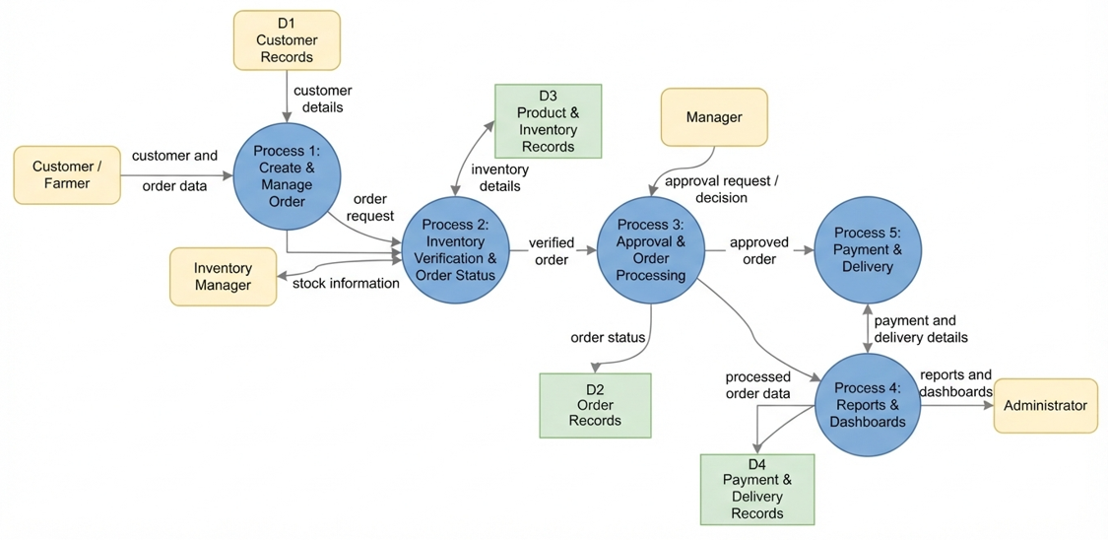

Here is how the diagram maps to the steps:
• Step 1, input: The customer or farmer submits customer and order details into Process 1, Create & Manage Order.
• Step 2, validation and storage: Process 1 validates the order information and stores customer details in D1 (Customer Records) and order details in D2 (Order Records). Process 2 verifies the product availability using D3 (Product & Inventory Records).
• Step 3, inventory verification: Process 2 checks the requested product quantity with the inventory manager and verifies whether sufficient stock is available. The verified order is then sent to Process 3.
• Step 4, approval routing: Process 3 sends applicable orders to the manager for approval and receives the approval or rejection decision. The order status is then updated in D2.
• Step 5, payment and delivery: Process 5 handles the payment and delivery information for approved orders and stores the details in D4 (Payment & Delivery Records). The payment and delivery status is communicated to the customer or farmer.
• Step 6, reports and dashboards: Process 4 reads the processed order, inventory, payment, and delivery information and provides reports and dashboards to the administrator and manager for monitoring and decision-making.

4. PROJECT DESIGN PHASE

4.1 Problem–Solution Fit
The AgriEdge Order Management System directly addresses fragmented agricultural order and inventory workflows by aligning user requirements, business processes, and automation using centralized system capabilities.
Problem Statement
Agricultural businesses often manage customer information, product orders, inventory, payments, and deliveries through separate spreadsheets, registers, phone calls, and manual processes. This can cause duplicate records, incorrect order details, stockouts, delayed order updates, and limited visibility into business operations. Order executives spend significant time on manual processing, inventory managers have difficulty monitoring stock levels, managers lack timely information for decision-making, and customers may not receive accurate updates about their orders.
Problem–Solution Mapping
Problem (User Behavior / Constraint) | AgriEdge Solution | Salesforce-Native Capability
Customer and order data scattered across spreadsheets and manual records | Centralized customer, product, and order records | Custom objects and relationships
Incorrect or incomplete order information | Data checked before records are saved | Validation rules and required fields
Manual inventory checking and risk of stockouts | Centralized inventory tracking and low-stock identification | Inventory Objects, Formula Fields and Flows
Slow and manual order approval | Orders are routed to the appropriate manager for approval | Approval Processes and Flow Automation
Unauthorized access to customer and business information | Users access only the information required for their roles | Profiles, Permission Sets, Roles and Sharing Rules
  No clear visibility into orders and inventory performance
  Real-time monitoring through reports and dashboards
  Reports and Dashboards
4.2 Proposed Solution
Parameter | Description
Problem | Manual order processing through spreadsheets, registers, and disconnected communication channels, leading to incorrect orders, stockouts, delayed approvals, and unclear order status.
Solution | Salesforce-based AgriEdge Order Management System managing customers, products, orders, inventory, approvals, payments, deliveries, and reporting on one platform.
Novelty | End-to-end automation of order validation, inventory checking, approval routing, order-status updates, and notifications using Salesforce-native tools such as Flows, Approval Processes, Validation Rules, and Lightning.
Social Impact | Improved customer experience through faster order processing, better product availability, accurate order status, and reduced administrative delays.
Revenue Model
  Institutional deployment through implementation, customization, licensing, and maintenance support for agricultural businesses and food-production organizations.
Scalability | Supports increasing numbers of customers, products, orders, inventory records, and users, with new business functions that can be added without redesigning the complete system.

4.3 Solution Architecture
The architecture integrates Salesforce objects, automation flows, approval processes, Apex components, reports, dashboards, and security layers. Users interact with the AgriEdge Order Management System through the Lightning interface, while automation processes orders, inventory activities, approvals, notifications, payments, and deliveries. The resulting information is stored in related custom objects, and the security layer controls access to customer, order, inventory, and business data based on user roles and permissions.
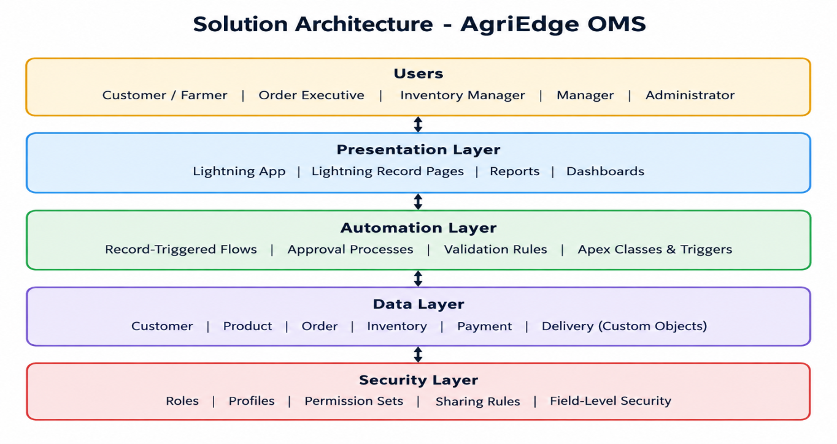

Here is how the layers work together:
• Users: Customers, order executives, inventory managers, managers, and administrators each get access based on their responsibilities.
• Presentation layer: The Lightning app, record pages, reports, and dashboards provide users with a simple interface to manage orders, inventory, and business information.
• Automation layer: Flows, approval processes, validation rules, and Apex components handle order processing, inventory checking, approvals, notifications, and status updates.
• Data layer: Customer, Product, Inventory, Order, Payment, and Delivery objects store the required business records and their relationships.
• Security layer: Profiles, permission sets, roles, and sharing rules control access at each level, ensuring users can view and manage only the information they are authorized to access.

5. PROJECT PLANNING & SCHEDULING

5.1 Project Planning
The project follows the Agile methodology. Work is organized as Epics → User Stories → Story Points and delivered in sprints. Progress is tracked through completed tasks, and sprint outcomes are used to plan and estimate the remaining work.
Product Backlog and Sprint Schedule
Sprint | Functional Requirement (Epic) | User Story Number | User Story / Task | Story Points | Priority | Team Members
  Sprint-1
  Developer Setup
  USN-1
  As a system administrator, I want to create and configure the Salesforce developer environment so that I can develop and test the AgriEdge Order Management System.
  1
  High
  Member1
  Sprint-1
  Data Management
  USN-2
  As an admin, I want to create custom objects for Customer, Product, Inventory, Order, Payment, and Delivery so that AgriEdge business data can be stored and managed efficiently.
  5
  High
  Member2
  Sprint-2
  Data Management
  USN-3
  As a user, I want dedicated tabs for customers, products, inventory, orders, payments, and deliveries so that I can easily navigate between business records.
  3
  High
  Member3
  Sprint-2
  Data Management
  USN-4
  As an admin, I want to create relevant fields for customers, products, inventory, and orders so that complete and accurate business information can be captured.
  5
  High
  Member4
  Sprint-2
  Data Management
  USN-5
  As an admin, I want to define relationships between customers, products, inventory, and orders so that related business activities can be tracked efficiently.
  5
  High
  Member1
  Sprint-2
  App Management
  USN-6
  As a user, I want a centralized Lightning App so that I can access AgriEdge order and inventory operations from one interface.
  3
  High
  Member4
  Sprint-3
  Process Automation
  USN-7
  As a system, I want validation rules for customer, product, inventory, and order information so that incorrect or incomplete records are prevented.
  3
  High
  Member2
  Sprint-3
  Process Automation
  USN-8
  As a system, I want automated flows to process orders and update order statuses so that manual processing effort is reduced.
  5
  High
  Member4
  Sprint-3
  Process Automation
  USN-9
  As a manager, I want an approval process for applicable orders so that orders are reviewed before further processing.
  5
  High
  Member1
  Sprint-4
  Apex Development
  USN-10
  As a system, I want Apex classes and triggers to handle complex order and inventory operations so that business rules can be processed automatically.
  5
  High
  Member3
  Sprint-5
  Security
  USN-11
  As an administrator, I want role-based security and permissions so that users can access only the customer, order, inventory, and business information relevant to their responsibilities.
  5
  High
  Member2
  Sprint-6
  Reports & Dashboards
  USN-13
  As a manager, I want reports and dashboards showing order trends, inventory levels, low-stock products, and order status so that I can monitor business performance and make informed decisions.
  4
  High
  Member4

Epic Summary
Epic | Stories | Story Points
  Developer Setup
  USN-1
  1
  Data Management
  USN-2 to USN-6
  21
  Process Automation
  USN-7 to USN-9
  13
  Security
  USN-11
  5
  Batch & Scheduled Processes
  USN-12
  5
 | USN-13 | 4
  Reports & Dashboards
Total | 13 stories | 49

6. PROJECT DEVELOPMENT PHASE

Milestone 1: Salesforce Developer Account Creation
Definition: A free Salesforce Developer Edition org is the working environment where the entire AgriEdge Order Management System is built, tested, and demonstrated. It provides the platform required to configure objects, automation, security, reports, and dashboards.
Key steps:
• Sign up at developer.salesforce.com/signup
• Verify the email and set a password
• Log in and open Setup
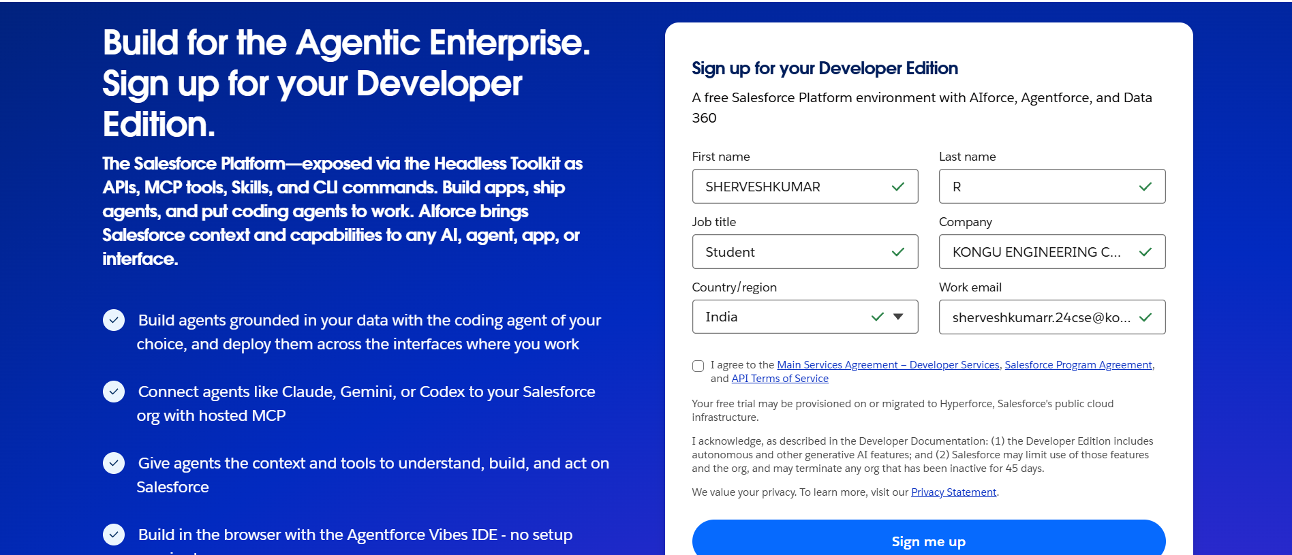
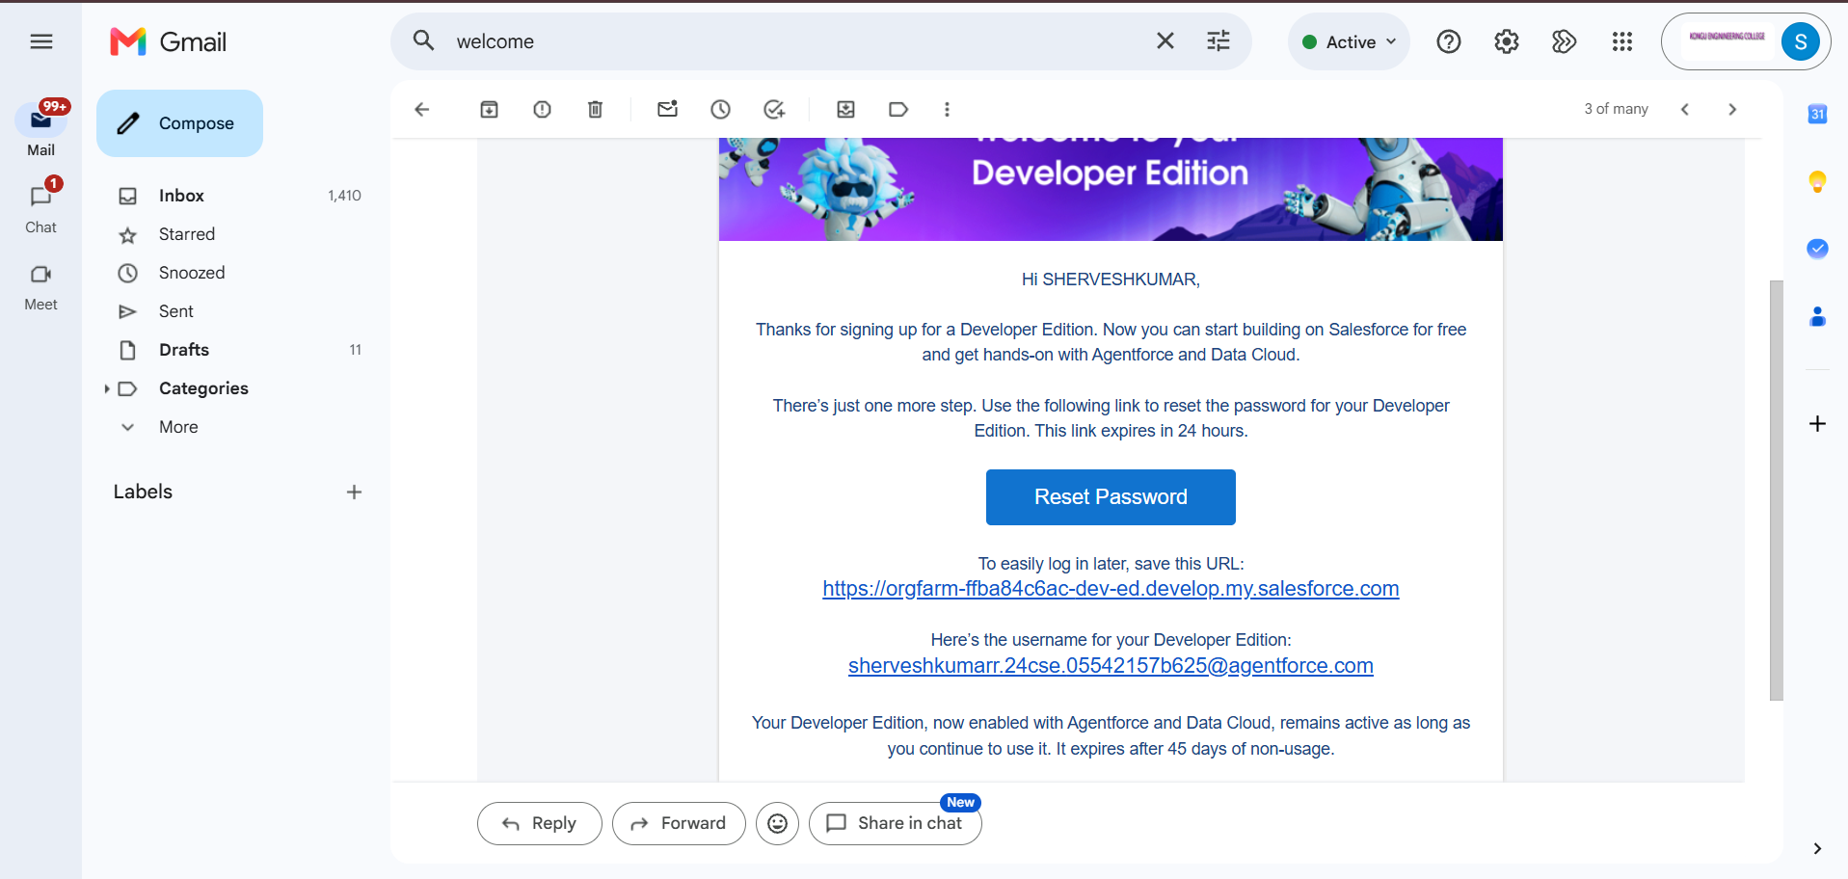

Milestone 2: Custom Object Creation
Definition: Custom objects store the main business information required by AgriEdge. The system uses objects such as Customer, Product, Inventory, Order, Payment, and Delivery to manage the complete order lifecycle.
Key steps:
• Setup > Object Manager > Create > Custom Object
• Enter the label, plural label, and record name
• Enable options such as Allow Reports, Allow Search, and Launch New Custom Tab Wizard
• Create the required objects for the order management process
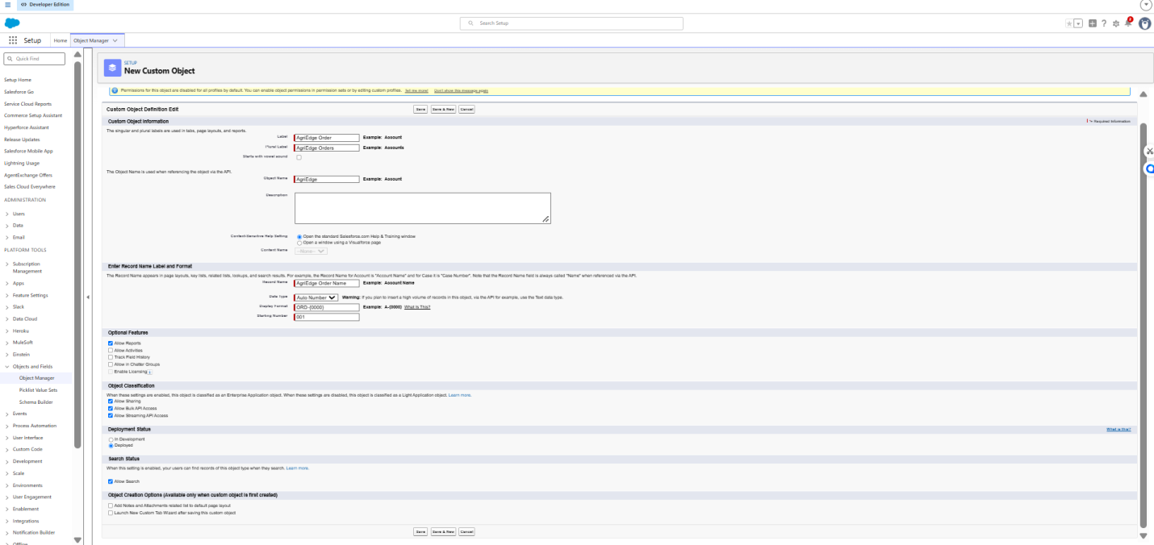
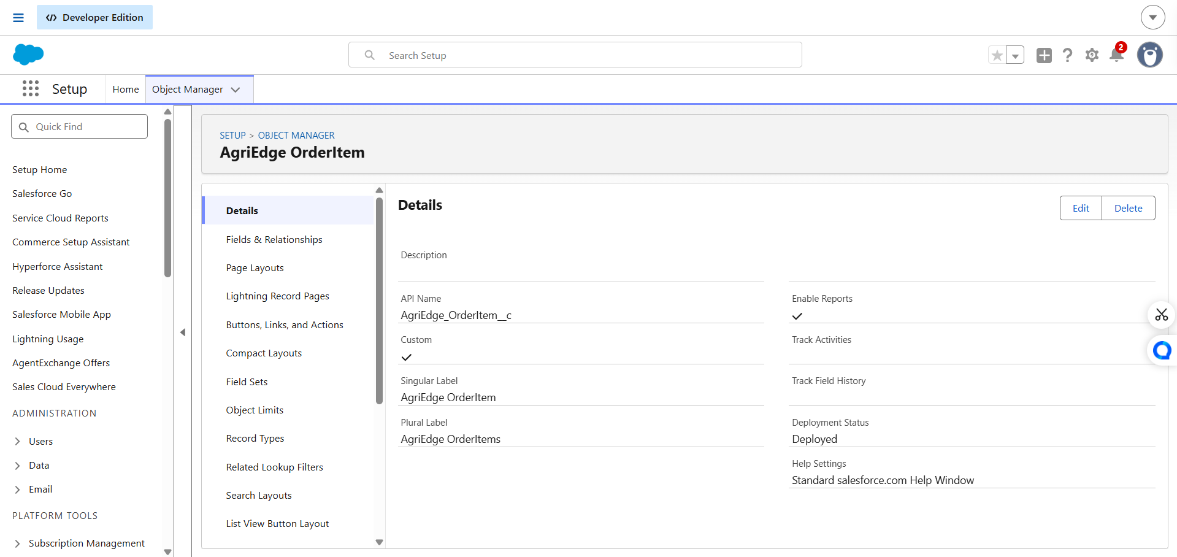

Milestone 3: Tabs Creation
Definition: Tabs provide navigation shortcuts to access records stored in each object. Dedicated tabs allow users to easily move between customers, products, inventory, orders, payments, and deliveries.
Key steps:
• Setup > Tabs > Custom Object Tabs > New
• Select the object and choose a tab style
• Set visibility for required profiles
• Add the tabs to the AgriEdge application
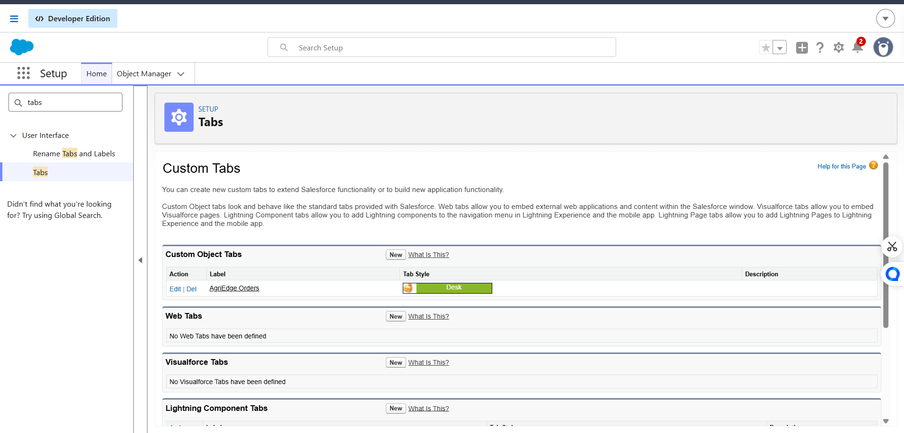
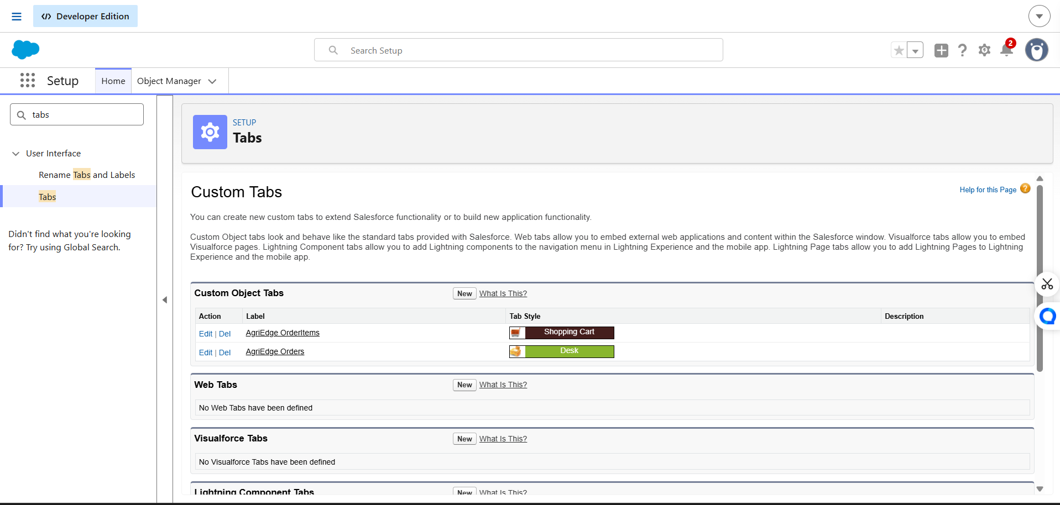

Milestone 4: Lightning App Creation
Definition: A Lightning App groups related tabs and features into a single workspace. The AgriEdge application provides users with a centralized interface for managing customers, products, orders, inventory, and related operations.
Key steps:
• Setup > App Manager > New Lightning App
• Set the application name and navigation style
• Add the required object tabs, Reports, and Dashboards
• Assign the application to appropriate user profiles
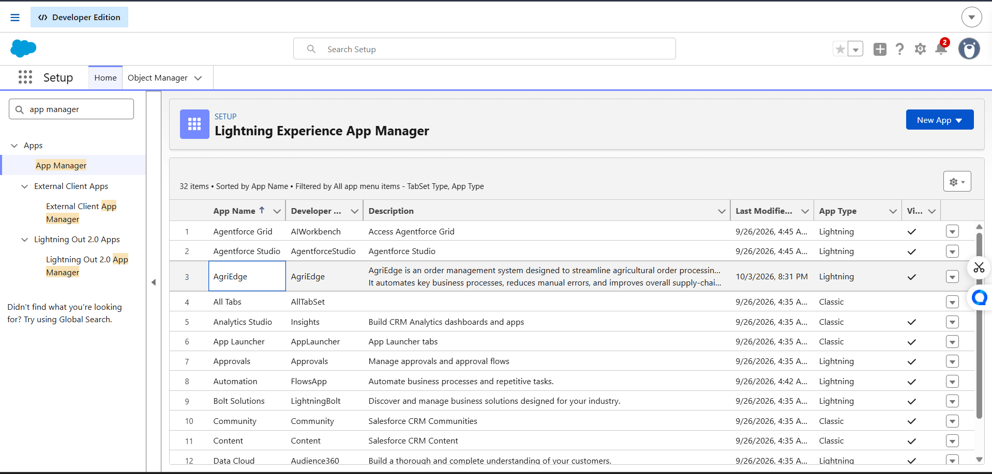

Milestone 5: Fields Creation
Definition: Fields store individual pieces of information within each object. They capture customer details, product information, inventory quantities, order status, payment details, and delivery information accurately.
Key steps:
• Object Manager > Select Object > Fields & Relationships > New
• Choose the required data type such as Text, Email, Date, Picklist, Currency, or Number
• Set field names and required fields
• Add suitable picklist values such as Pending, Approved, Processing, Delivered, and Cancelled
• Set field-level security and add fields to page layouts
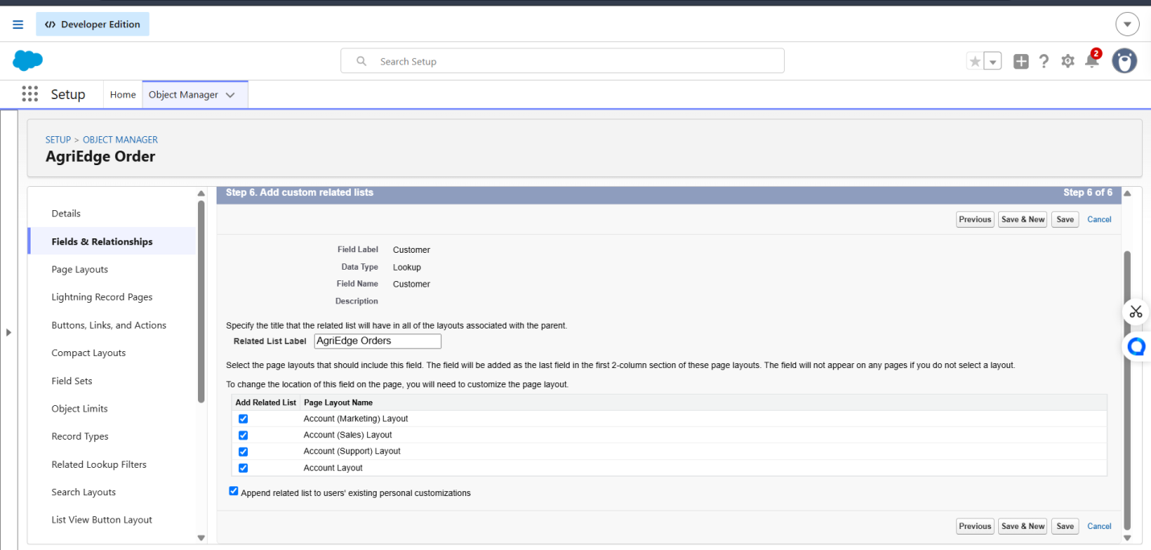
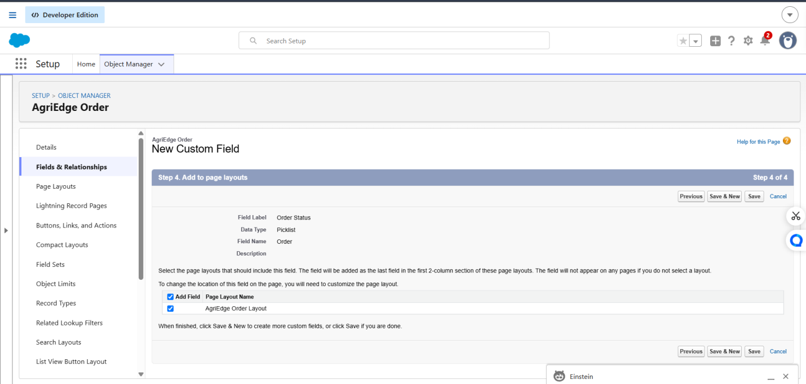

Milestone 6: Data Management – Field Creation & Field Types
Definition: Fields store individual pieces of information in each AgriEdge object. Different field types are selected based on the type of data required, such as customer details, product information, order status, inventory quantity, payment, and delivery information.
Key steps:
• Go to Setup > Object Manager > Select Object > Fields & Relationships > New.
• Select the appropriate Field Type for the required data.
• Enter the Field Label and configure the field properties.
• Add required Picklist values for fields such as Order Status, Payment Status, Delivery Status, and Product Category.
• Set Field-Level Security and add the field to the required Page Layout.
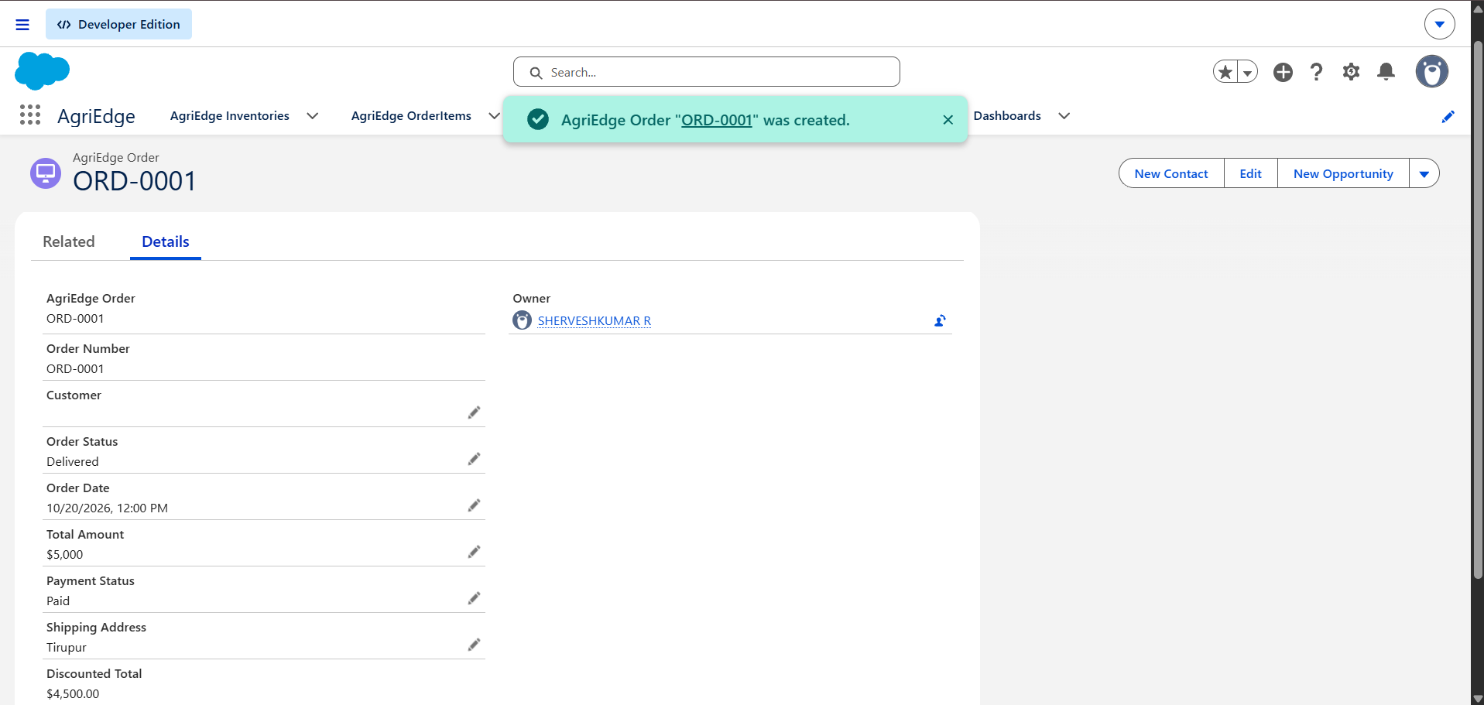
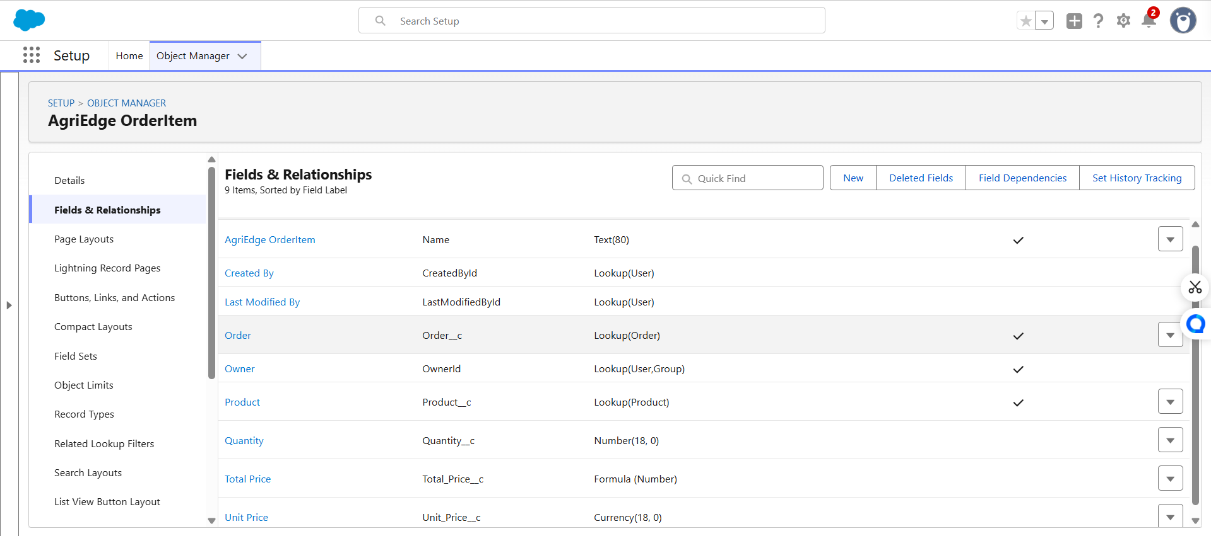

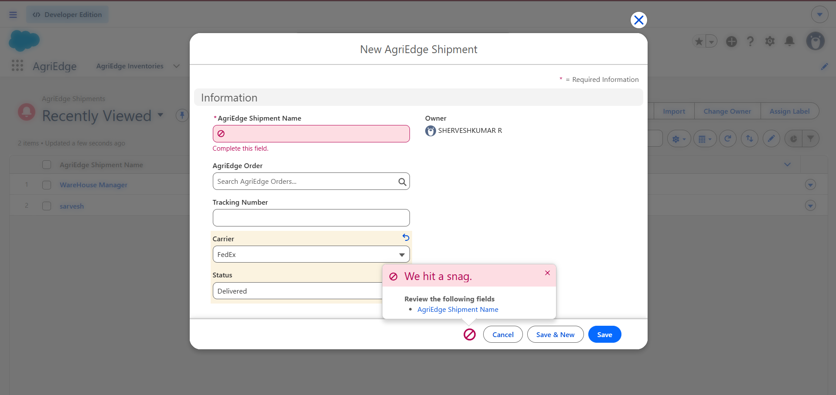

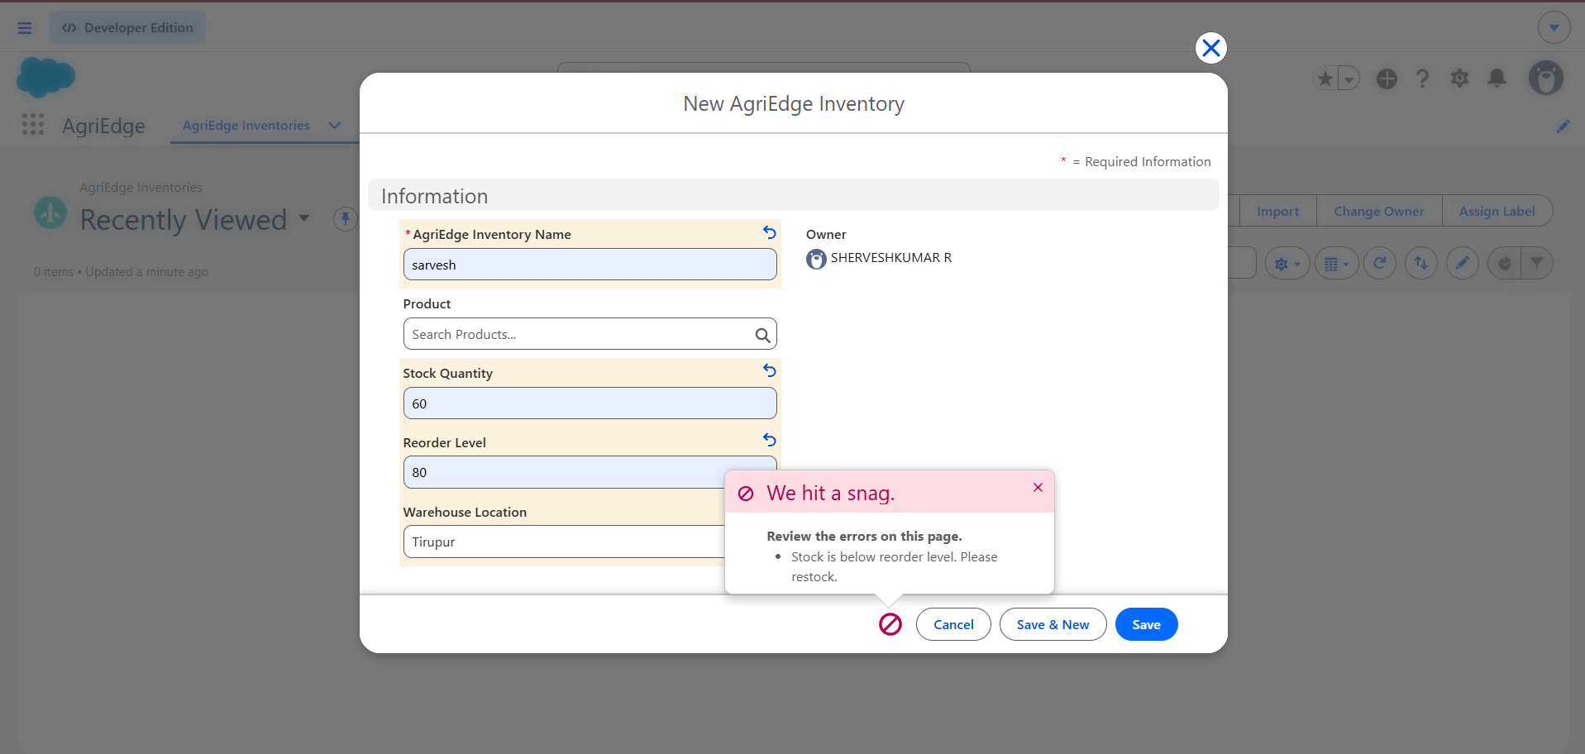

Milestone 7: Data Security – Roles
Definition: Roles control the level of record access for different users in the AgriEdge system. They help ensure that users can access the customer, order, inventory, and business records required for their responsibilities.
Key steps:
• Go to Setup > Roles > Set Up Roles.
• Create roles such as Sales Representative,Warehouse Manager and Finance Team.
• Arrange the roles in the Role Hierarchy according to their responsibilities.
• Assign users to their appropriate roles.
• Configure Organization-Wide Defaults and Sharing Rules to control record visibility.
• Test the access levels to ensure users can view and manage only the records permitted for their roles.

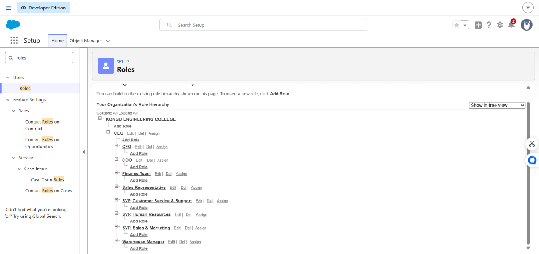

Milestone 8: Data Security – Profiles
Definition: Profiles define the permissions and access levels of users in the AgriEdge system. They control which objects and features users can view, create, edit, or delete based on their responsibilities.
Key steps:
• Go to Setup > Profiles.
• Select the required profile or create a custom profile.
• Configure Object Permissions such as Read, Create, Edit, and Delete.
• Configure Field-Level Security to control access to specific fields.
• Set appropriate App and Tab visibility for each profile.
• Assign the profiles to the respective users and test their access permissions.

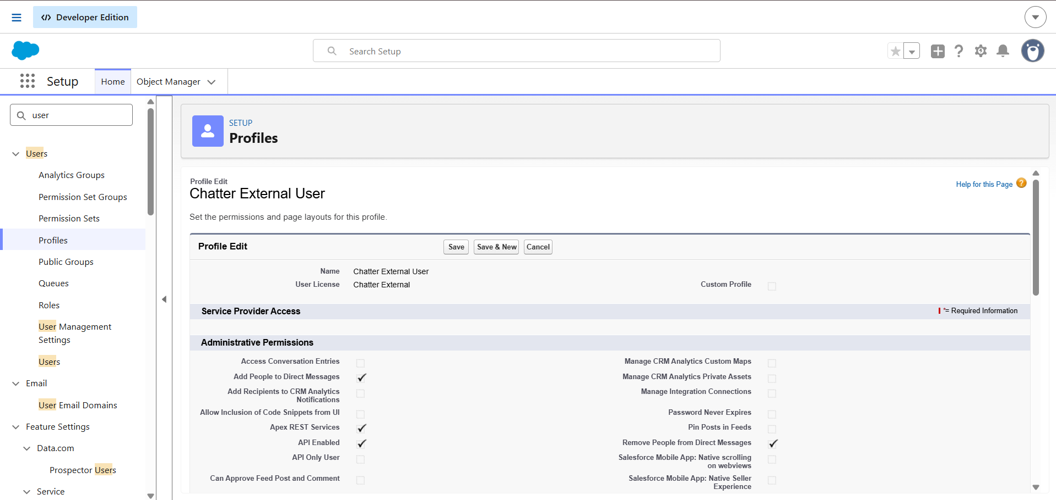

Milestone 9: Data Security – Users
Definition: Users are individual accounts created for people who access the AgriEdge system. Each user is assigned an appropriate role and profile to control access to customers, orders, inventory, and other business information.
Key steps:
• Go to Setup > Users > Users.
• Click New User and enter the required user details.
• Assign the appropriate Role and Profile based on the user's responsibilities.
• Set the required Permission Sets for additional access.
• Activate the user account and verify the assigned permissions.
• Test the user login and confirm that the user can access only the required records and features.

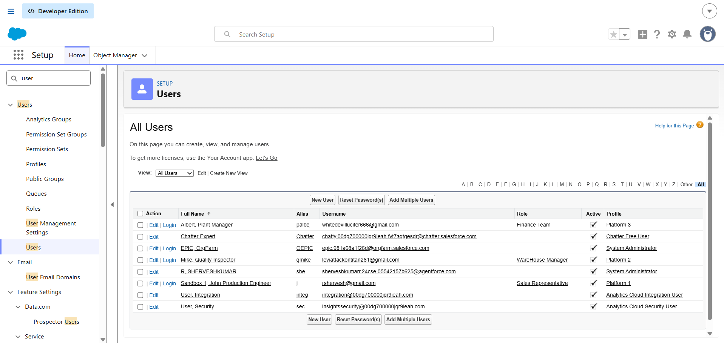

Milestone 10: Data Security – Field-Level Access
Definition: Field-level access controls which users can view or edit specific fields in the AgriEdge system. It protects sensitive information by allowing access only to users who require it for their responsibilities.
Key steps:
• Go to Setup > Object Manager > Select Object > Fields & Relationships.
• Select the required field and open Set Field-Level Security.
• Set the field as Visible or Read-Only for the required profiles.
• Hide sensitive fields from profiles that do not need access.
• Save the settings and verify the field visibility using different user profiles.
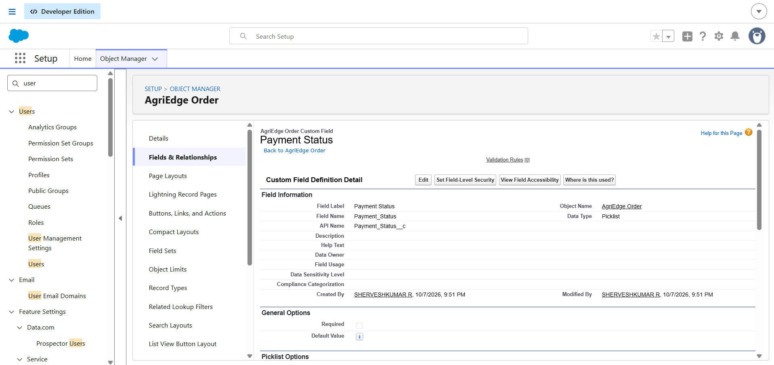

Milestone 11: Apex Class, Triggers & Testing
Definition: Apex Classes and Triggers are used to implement custom business logic in the AgriEdge system. Apex Test Classes verify that the implemented logic works correctly and helps ensure reliable order and inventory processing.
Key steps:
• Go to Setup > Apex Classes > New and create the required Apex Class.
• Create an Apex Trigger for the required object, such as Order or Inventory.
• Add the required business logic for order processing or inventory updates.
• Create an Apex Test Class to test the Apex Class and Trigger functionality.
• Run the test class and verify the test results and code coverage.
• Fix any errors and retest until the required functionality works correctly.

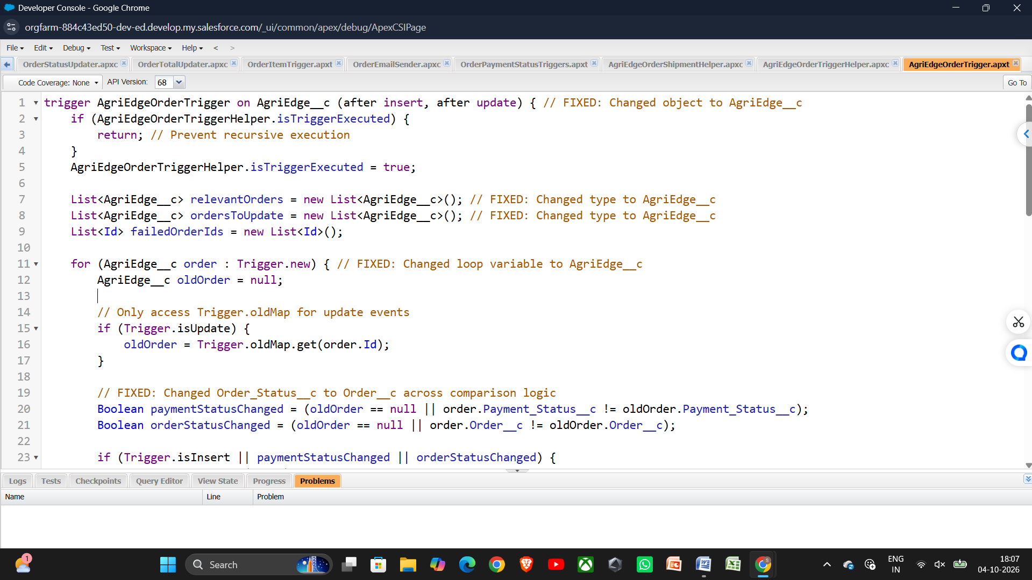
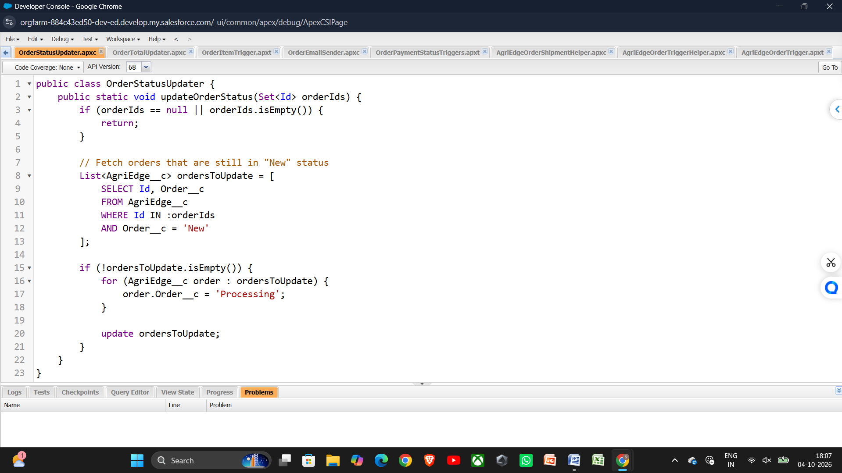

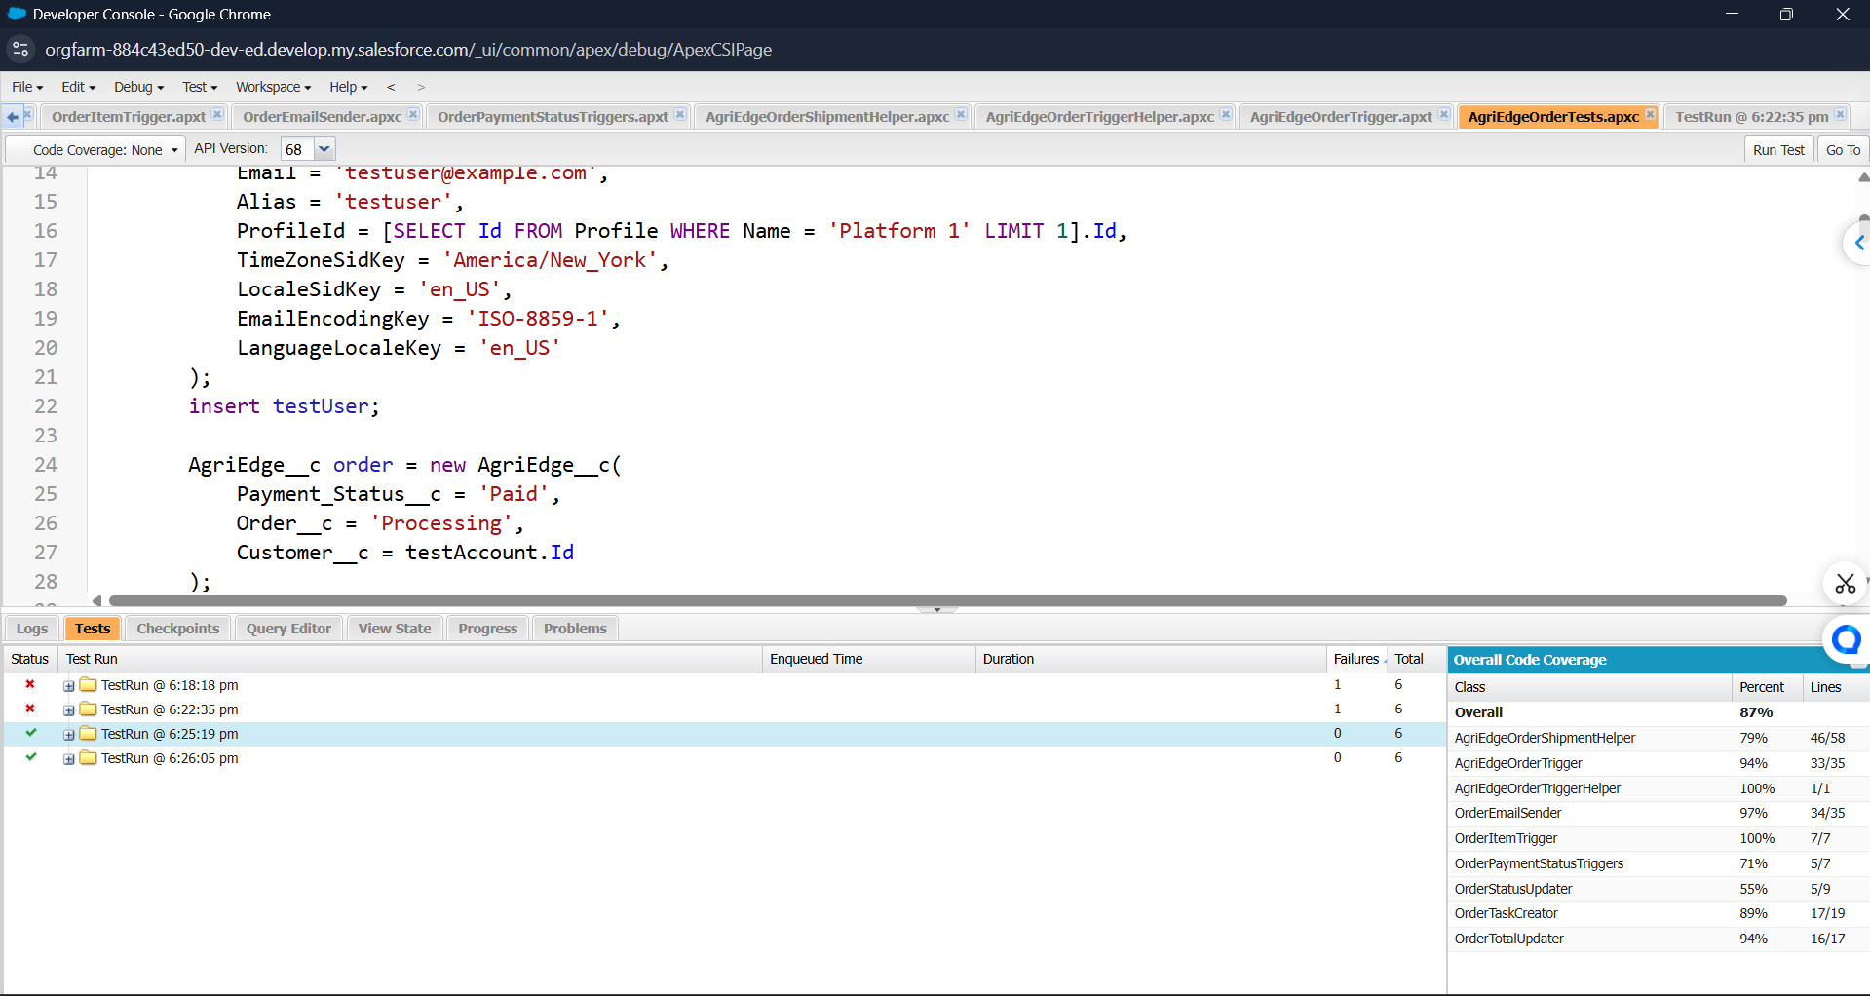

Milestone 12: Automation
Definition:
Automation uses Salesforce Flows and automated actions to reduce manual work in order processing. It automatically updates order information, manages order status, and performs required actions when order records are created or modified.
Key steps:
• Go to Setup → Flows → New Flow.
• Select Record-Triggered Flow and choose the AgriEdge Order object.
• Set the trigger conditions, such as when a new order is created or the order status changes.
• Add Decision, Update Records, Create Records, or Email Alert elements according to the required process.
• Connect the elements, Save and Activate the Flow.
• Create test orders and verify that the automation works correctly.

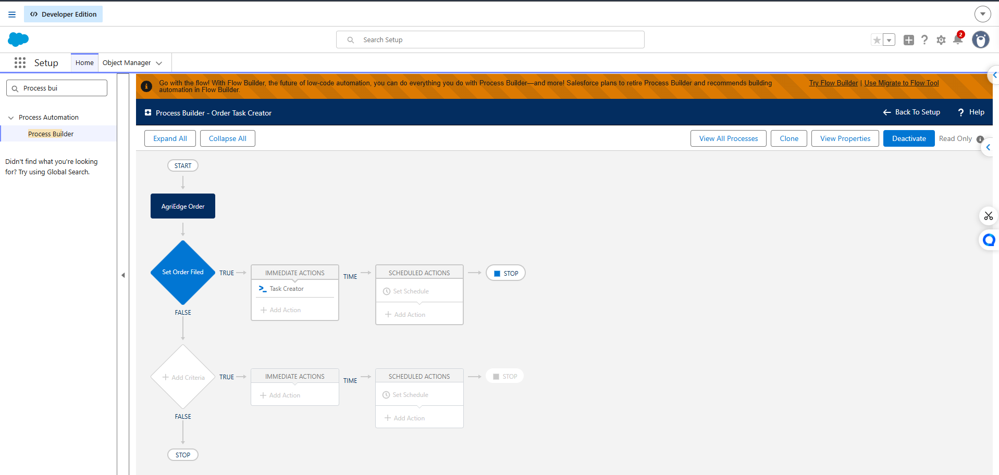

Milestone 13: Conclusion
Project Summary
The AgriEdge Order Management System replaces manual order handling, inventory tracking, and disconnected customer service processes with a centralized cloud-based system. It brings order processing, inventory management, customer support, automation, security, and reporting together so that the organization can manage agricultural products efficiently from one platform.
Outcomes and Benefits
• Efficiency: Reduces manual order entry and automates repetitive order-processing activities.
• Accuracy: Validation rules and automated updates reduce incorrect order and inventory records.
• Speed: Automated order status updates and notifications help process orders faster.
• Transparency: Users can view current order and inventory information without depending on manual updates.
• Customer Service: Customer service staff can access order information quickly and respond to customer queries more effectively.
• Scalability and Maintainability: The system can support additional products, customers, orders, and users as the organization grows.
Possible Future Enhancements
• Online customer portal for customers to place orders, track order status, and view order history.
• Automated inventory alerts to notify staff when product quantities reach the reorder level.
• Mobile access for staff to manage orders and inventory while working in the field or warehouse.
• Advanced analytics for identifying order trends, product demand, inventory movement, and supply chain performance.
• Integration with payment systems for faster and more convenient order payments.
• Integration with logistics systems to track deliveries and provide customers with shipment updates.
• AI-assisted features such as demand forecasting, inventory prediction, and intelligent product recommendations.
Closing Statement
The AgriEdge Order Management System achieves its core objectives by providing centralized order processing, accurate inventory tracking, automated workflows, secure data access, and real-time reporting. The system provides a strong foundation for improving agricultural supply chain operations and delivering better customer service.

